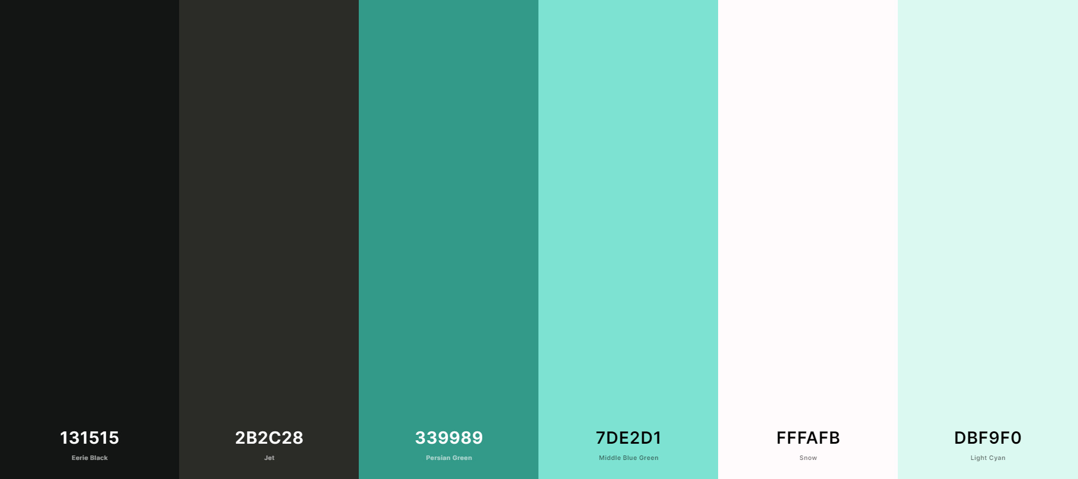

font-family: 'Abril Fatface', cursive;

font-family: 'Baloo Bhaijaan 2', cursive;

font-family: 'Bebas Neue', cursive;

font-family: 'Dosis', sans-serif;

font-family: 'Open Sans', sans-serif;

font-family: 'Roboto Condensed', sans-serif;

|  |  |  |  |
| --- | --- | --- | --- |
| Html tag | Font family | grootte | color |
| H1 | font-family: 'Baloo Bhaijaan 2', cursive; | 4rem |  |
| H2 | font-family: 'Baloo Bhaijaan 2', cursive; | 3.5rem |  |
| H3 | font-family: 'Baloo Bhaijaan 2', cursive; | 3rem |  |
| H4 | font-family: 'Baloo Bhaijaan 2', cursive; | 2.5rem |  |
| H5 | font-family: 'Baloo Bhaijaan 2', cursive; | 2rem |  |
| H6 | font-family: 'Baloo Bhaijaan 2', cursive; | 1.5rem |  |
|  |  |  |  |